Shabbos Stories for
Parshas yisro 5778
Volume 9, Issue 21 18 Shevat 5778/ February 3, 2018
Printed L’illuy nishmas Nechama bas R’ Noach, a”h

For a free subscription, please forward your request to keren18@juno.com
An Antwerp Version of the “Too Many Children?” Story
By Rabbi Reuven Semah

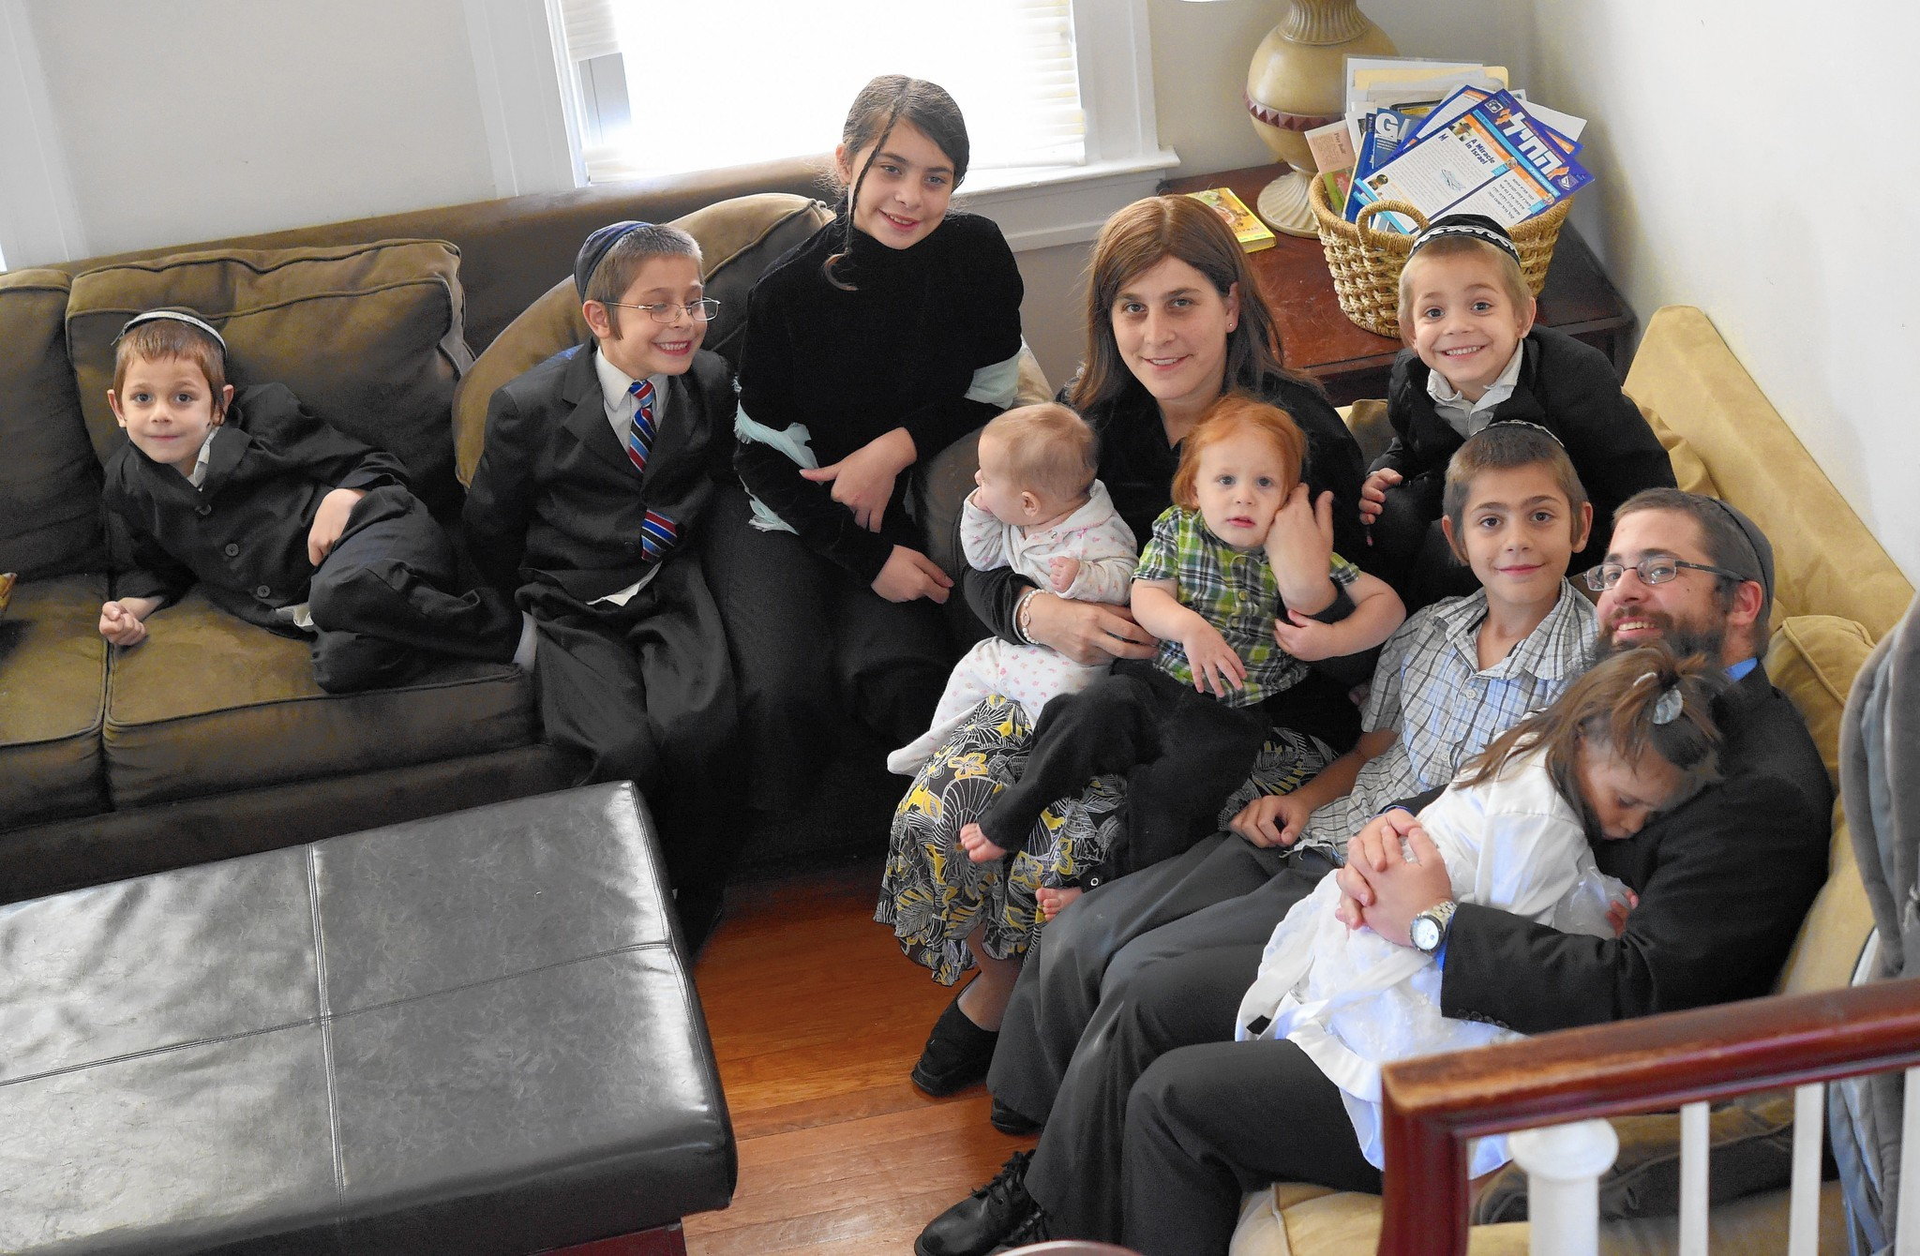
Photo of a large Jewish family, but not the one in the story below.

Rabbi Moshe Kormornick tells the following true story, which occurred a
few years ago in Antwerp, that shows just how a husband and wife were able to actualize this message and enjoy the results of Hashem being right there with them.
Chaim and his wife sat down at their table after a long hard day. “Baruch Hashem, we have been blessed so much and I’m not complaining,” the wife announced. “It’s just that we now have 12 children and there is no more room in the house, and we really can’t afford any more children. Although we’re coping, isn’t 12 enough?”
The husband lovingly sympathized with his wife and then began to speak about the importance of relying on Hashem. “Since you are healthy and our only concern is a financial one,” he suggested, “I think we should leave everything in Hashem’s Hands, for if He blesses us with another child, He will surely provide the means of support.”
The woman accepted her husband’s words and within a short period of time, she was delighted to find out she was pregnant again.
On the day the baby was born, in the same hospital, an especially wealthy gentile died leaving no heirs or family. Years earlier, he had declared in his will that all of his money should be given to the largest family in Antwerp, since he had never married and had no family to give the money to.
Now there were several families in Antwerp with 12 children, but no family with thirteen children. Well, at least there was no family until the day the gentile died, when there was one Jewish family who had officially become the largest family in the city, having just being blessed with their thirteenth child.

(Reprinted from the Parshat Bo 5778 email the Jersey Shore Torah Bulletin, courtesy of Shabbat Shalom from Cyberspace. I read similar versions of the above story several years ago, but the Jewish family was living in Switzerland when they became the largest household in that European country.)
Hashgacha Pratis #23
A Jew Aboard a Downed
U.S. Naval Submarine
By Rabbi Yosef Weiss



Lt. Shmuel Kahan began his active duty with the U.S. Navy in the early 1960’s. A Rav and a Torah scholar, R’ Shmuel remained firm in his Torah principals throughout his military career, and gained the admiration and respect of both his superiors and subordinates. All of his religious needs were accommodated. He also gained much esteem with his superiors when, on many occasions, his astute and incisive mind formulated brilliant solutions to problem which his superiors grappled with.
One day, on his way to the Brooklyn Navy Yard to board his submarine, he passed an old Army-Navy surplus store. He peered into the window and saw an old hand generator covered with rust and dirt. On impulse, he asked for the price. The store owner explained that the item was from WWI and the price was $35.
R’ Shmuel asked how much it would cost to have it refurbished. The proprietor said he could make it look as good as new, but it would increase the price to $75. R’ Shmuel felt inexplicably drawn to purchase this item, and agreed to the deal, insisting however, that the generator be refurbished to perfect condition.
One week later, he picked up his newly furbished hand generator; the owner threw in a handsome leather case. After that, R’ Shmuel always took his generator with him whenever he boarded a submarine, stowing it under his bunk bed.
During the Cuban missile crisis of 1962, R’ Shmuel was stationed in Guantanamo Bay, Cuba. One day, during a routine maneuver on the submarine which R’ Shmuel commanded, an ordinary dive suddenly went awry. A complete loss of power sent the submarine sinking straight down to the bottom of the ocean. R’ Shmuel realized that they were quickly reaching the depth at which the submarine would no longer be able to withstand the terrific ocean water pressure. R’ Shmuel silently recited Tehillim while he managed to calm his frightened crew. The vessel suddenly shuddered and a loud thump resounded through the submarine. R’ Shmuel assured them that they had landed on a small ledge sticking out from one of the underwater mountains, fortunately saving them from reaching the breaking pressure point.
But his sea legs told him that any sudden movement could cause the vessel to slip off the ledge and resume its sinking to the ocean floor. He ordered his men to hit the deck and remain perfectly still. The fear and tension were palpable. Suddenly, a 17- ear-old sailor panicked and screamed hysterically. He was slapped and calmed. The hysteria was controlled, but R’ Shmuel sensed the tension of his crewmen was growing more intolerable by the minute.
He ordered that every crewman be given a pistol with a single bullet; in case the sub began to implode, each person would have the option of ending it all with a bullet, instead of suffering death by drowning.
One boson’s mate asked R’ Shmuel, “Sir, why aren’t you taking a pistol?” R’ Shmuel replied, “I’m not taking a pistol because I don’t need one. I don’t know about the rest of you, but I’m coming out of this alive. I have complete faith in our Creator.”
R’ Shmuel buoyed their confidence. Hours passed, and without electrical power, they had only a few days of air left. R’ Shmuel had to find a solution – and then it came to him in a flash. The generator under his bunk bed!
His crew was astonished as he hooked it up to radio the base. “Gray lady down – S.O.S,” he transmitted. He also signaled that an electrical cable needed to be lowered. Communication was only one way at that point. They waited tensely for several days.
Finally, they heard something tapping on the sub. The electric cable! A crewman was sent in diving gear to very gently snag the cable and pull it into the torpedo room, carefully avoiding any sudden movement that would cause the sub to plunge. Finally, the submarine, with a renewed burst of electricity, surfaced above the water.
Close to a hundred ships had gathered at that spot, waiting to lend a hand. As the crew emerged, all the ships simultaneously blasted their whistles, rocketing streams of water into the air in salute.
Admiral O’Donnell saluted Lt. Shmuel Kahan. Then, putting all formality aside, the Admiral heartily embraced his friend. “I knew I could count on you,” he whispered. R’ Shmuel fervently offered thanks to Hashem for His Divine Providence. (Visions of Greatness, Vol. 5)

Reprinted from the Parshas Bo 5778 email of The Weekly Vort.

How the Simple Villager Changed His Ways
By Asharon Baltazar

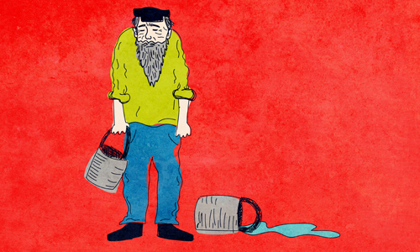
Illustrated by Sefira Ross

Our story takes us back 200 years to a small town in Russia. There was a simple villager who had hired a Torah scholar to tutor his children, a common arrangement for people of means living far from large cities or towns with organized Torah schools. Although the villager was a simple Jew, he hoped that his children would one day surpass his meager knowledge of Torah and Judaism. The tutor was a devoted student of the first Chabad Rebbe, known as the Alter Rebbe. A short while before the High Holidays, the teacher told his employer that he was traveling and would not be available for the season.
“What? Why?” asked the villager. “People are arriving from the other hamlets, and I thought you would join us here for services. In fact, we would be honored if you could be our cantor and shofar blower. We are simple villagers and can’t do any of that.”
“I am going to my rebbe,” explained the chassid, further stumping the villager.
“Your rebbe? How could you have your own rebbe?” asked the villager, who was accustomed to referring to the teacher as “Rebbe.” How could the rebbe have a rebbe of his own?
Seeing his employer’s confusion, the tutor described the uniqueness of a chassidic rebbe, someone who is righteous and cares dearly for others, like a shepherd for his flock. Since the rebbe is the head of the Jewish people, he continued, it is appropriate to visit him at the head of the New Year.
Curious, the villager said, “I want to come too!”
The prospect of a travel companion brightened the tutor’s mood. Being a teacher, he barely eked out a living, and was glad to ride in the comfort of a cart rather than make the long trip on foot. Having packed provisions for the journey, the pair set out for the Alter Rebbe’s court.

Immediately after their wagon came to a stop outside the Alter Rebbe’s synagogue, an enthusiastic crowd formed around the newcomers, and the tutor was greeted with joy. Everyone wanted to shake his hand or exchange a friendly word. However, no one approached the villager. Upset, he watched from the side and sulkily observed the warmhearted welcome he did not receive.
In time, the holiday guests began queuing for their annual audience with the Alter Rebbe, during which they would receive personalized directives in the privacy of the rebbe’s room. Seeing that even his rebbe was standing in line to speak with the rebbe, the villager asked to be admitted as well.
Stepping through the door of the Alter Rebbe’s study, the villager was greeted by an imposing man with a white beard. The rebbe did not say anything. The villager, unsure of what to say, also stood by wordlessly. For a few moments, the two stared at each other in silence.
“Nu?” questioned the Alter Rebbe.
The villager still did not say anything.
“Nu?” repeated the Alter Rebbe.
Nothing.
“Nu?”
Unable to hold back, the villager finally blurted out angrily, “Why are you repeating ‘Nu’”?
The Alter Rebbe calmly replied to the villager, speaking in a sing-song, as was his wont: “Sometimes it happens that a Jew sins. He committed this sin and this sort of sin….” And the Alter Rebbe listed all of the villager’s misdoings.
The villager was stunned. How did the Alter Rebbe know what he had done in the privacy of his home?
His suspicion turned to his rebbe, the tutor, who had been admitted to the Alter Rebbe before him. He must have told him.
Fuming, the villager left the rebbe’s presence and located the teacher, who suddenly found himself being berated and accused by his employer.
“You comfortably live in my home to the point where you lack nothing,” the villager fumed, “and yet you run to your rebbe and shamelessly tell him everything there is to know about me! Imagine that! From today you can begin looking for work someplace else. I don’t want to see you anywhere near my doorstep.”
The villager’s tirade left the teacher surprised and hurt. But the teacher also felt bad for his employer’s distress and embarrassment. After all, he had brought him to the rebbe, and his employer had always treated him kindly.
Entering the rebbe’s room for a second time, the teacher asked the Alter Rebbe to assure the villager that he never said a word about him. The Alter Rebbe quickly summoned the villager.
“There was no reason to get angry with him,” the Alter Rebbe said to the villager. “He never told me a thing.”
“So how did you know?” the villager asked.
“When did I say it was you who did those things?” said the Alter Rebbe. “I simply stated that a Jew is liable to commit those sins. How am I supposed to know if you’ve actually done them?”
The Alter Rebbe’s words shook the villager to his core. “Rebbe! What you’ve said is true. All the sins you’ve listed are in fact true about me!”
Hearing the villager’s sincere wish to repent, the Alter Rebbe wrote up a series of steps for spiritual growth for the simple villager who then, in time, became one of the Alter Rebbe’s closest followers. Adapted from Shemu’ot Vesippurim Vol. 1, page 34

Reprinted from the Parshat Va’eira 5778 email of Chabad.Org Magazine.

L’Maaseh
The Talmid Chacham who Wanted to be a Shamas Sheni

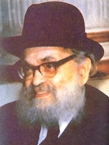
Rabbi Akiva Eiger, zt”l Rabbi Yaakov Kamenetsky, zt”l

Rav Yaakov Kamenetsky, zt”l, would relate the following story and the practical lesson in Middos that he learned from it. In the first years after his Chasunah, Rav Akiva Eiger, zt”l (1761-1837), lived in the city of Lissa where he was supported by his father-in-law. The Rav of Lissa was Rav Yaakov Loberbaum, zt”l, the author of the Nesivos HaMishpat.
When Rav Akiva Eiger’s years of support ended, it was time for him to find a way to support his family. He looked for an easy job that would require only a minimal amount of his time so that he would still have most of the day to learn Torah, and Rav Akiva heard that the main Shul in Vilna was looking for a Shamas Sheini, an assistant Shamas.
The job would consist of collecting the Siddurim and Chumashim from the tables and regularly sweeping the floor. Rav Akiva Eiger decided that this would be the perfect job for him. He approached the Rav of the city, the Nesivos, and asked for a letter of recommendation that he could send to help him get the job.
The Nesivos immediately recognized that this job was completely beneath the dignity of the future Gadol HaDor, but since he didn’t want to refuse Rav Akiva Eiger, he wrote the letter. He described Rav Eiger’s greatness in Torah and his sterling Middos, and at the end of the letter, he wrote that he is certain that Rav Akiva Eiger was capable of serving as the Shamas Sheini.
When the Gabbaim of the Vilna Shul read the letter, they had a dilemma, as they were seeking an assistant to the Shamas, not someone who was fit to be the Av Bais Din. After much contemplation, they decided to send a letter to the Nesivos saying that they were ready to accept Rav Akiva Eiger as the Shamas Sheini, but they first needed the Nesivos to rule on a Halachic question that they had.
If Rav Akiva Eiger were to get the position, the Shamas Rishon, the main Shamas, was a simple and unlearned Jew. He undoubtedly would not feel comfortable giving instructions to his assistant who is a Talmid Chacham, and they wanted his advice as to how to handle that situation.
When the Nesivos read the letter, he called Rav Akiva Eiger over and showed it to him, and said, “I think that you should rule on this question, and I will send a reply to Vilna based on your answer.” After thinking about it for a little, Rav Akiva decided not to take the position.
When Rav Yaakov Kamenetsky would finish telling over this story, he would explain, “At times a person decides to take a certain approach to an issue because he feels that this approach would be good for his Ruchniyus. However, if this approach would in any way hurt the feelings of another person, it is important to reassess the situation and decide if it is worth it to continue, and this is exactly what Rav Akiva Eiger did!”

Reprinted from the Parshas B0 5778 email of Torah U’Tefilah: A Collection of Inspiring Insights compiled by Rabbi Yehuda Winzelberg.
The Brisker Rav’s Compass

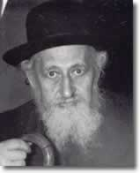

The Brisker Rav [Rabbi Yitzchok Zev Soloveitchik, 1886-1959], zt”l, once traveled to Switzerland for health reasons. Those who accompanied him were amazed by his behavior. When they arrived, it was a new country to them, and everyone wanted to spend some time looking around and taking in their new surroundings. Especially, in a place like Switzerland which is famous for the spectacular mountain views.
However, this was not so with the Brisker Rav. The first thing he did when he got there was to take out a compass from his pocket. He wanted to determine which direction was east— the direction of Eretz Yisroel, in order to know which way he should stand during Davening.
Hashem’s Presence was always foremost in the Brisker Rav’s mind, and he taught his students that wherever a Jew travels, his first step in the new place should not be toward anything worldly or for his own enjoyment and pleasure, but rather it must be to do Hashem’s will. Anything that is not directly connected with this goal of serving Hashem is only secondary!

Reprinted from the Parshas B0 5778 email of Torah U’Tefilah: A Collection of Inspiring Insights compiled by Rabbi Yehuda Winzelberg.
Middos
Rav Shteinman’s Kitchen


Rav Shteinman, zt”l, greeting visitors in his Bnei Brak home.

Rav Aharon Yehuda Leib Shteinman, zt”l, lived very simply, and his home and lifestyle demonstrated this. Anyone who visited Rav Shteinman’s small apartment in Bnei Brak was amazed at the humble conditions he lived in, and would describe the dilapidated closets and cabinets, and walls with peeling paint. Once, the Israeli Ambassador to Japan needed to discuss an important matter with Rav Shteinman and went to see him. When he left, he marveled at the tiny residence and was astonished at the condition of the apartment in which one of the leading sages of Israel lived in and said, “I have never seen anything like it in my life.”
For decades, Rav Shteinman slept on a plank bed that he had received when he moved to Israel, and only recently, due to his advanced age, was his bed replaced by a hospital bed.
Rav Shteinman learned on a simple stool in which he had the legs extended, and this was so that his feet would not reach the floor and reduced the chances of him falling asleep while he was learning.
The family received many offers from others to purchase their home for a large amount of money so they could buy a nicer place to live, and they got many offers of donations of nicer furniture, but Rav Shteinman always refused, insisting that he had everything he needed and seeks no more.
This remarkable way of living a simple life was an inspiration to many others. Once, a couple had come to seek his advice regarding an issue they were having in their marriage. They were in a conflict over whether or not they should invest in renovating their house.
When they came to see Rav Shteinman and were waiting to speak with him, the wife took one look at Rav Shteinman’s kitchen and immediately cancelled their appointment, and said that it was no longer necessary for them to speak with him. She said, “If the Gadol HaDor can live this way, then so can I!”

Reprinted from the Parshas B0 5778 email of Torah U’Tefilah: A Collection of Inspiring Insights compiled by Rabbi Yehuda Winzelberg.

Story #1050
Struck By Lightning
From the Desk of Yerachmiel Tilles
editor@ascentofsafed.com

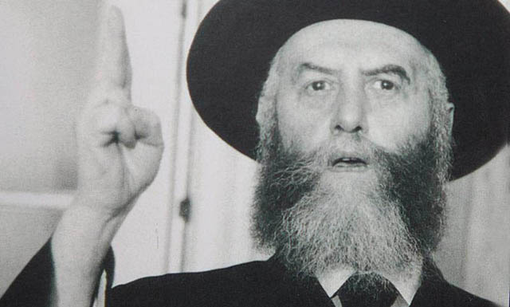
Rabbi Yosef-Yitzchak Shneersohn, zt”l, the Rebbe Rayatz [of Lubavitch]

The Rebbe Rayatz requested to be met at the station by "a fine Jew," but not a Chabad chasid as that would likely cause chaos.
Rabbi Yoel Hakohen R. Lipszye, was a shochet--a kosher slaughterer. In the 1930's he lived in Paris, France. He was friendly with Rabbi Shneur-Zalman Schneerson, a cousin of the Lubavitcher Rebbe at that time, Rabbi Yosef-Yitzchak Shneersohn [the Rebbe Rayatz]. R. Lipszye and Rabbi Zalman would study together on a regular basis.
One day, Rabbi Zalman showed R. Lipszye a telegram which he had recently received from the Rebbe's office. The Rebbe wrote that he would be coming to Paris to meet with a foot specialist. He asked that Rabbi Zalman should arrange for 'a fine Jew' to pick him up at the train station and take him wherever he needs to go. He specifically requested that it not be a Chabad chasid, as that would create too much chaos.
R. Lipszye was a Gerrer chassid, from a long line of Gerrer chasidim, so Rabbi Zalman asked him if he would be willing to be that person. Of course, R. Lipszye agreed.
When R. Lipszye picked up the Rebbe Rayatz at the train station, the Rebbe asked him his name, to which he responded: "Yoel ben Yitzchak Meir Hakohen." These were the only words R. Lipszye said to the Rebbe during the entire time he spent with him!
Despite the precautions, word did get out in Paris that the Lubavitcher Rebbe was there. Many people asked for appointments to meet him in private, known as yechidus. The Rebbe did agree to have one general yechidus session for all of those requesting together. Rabbi Zalman pointed out to R. Lipszye this would be an excellent opportunity for him to also enter the room for yechidus.
R. Lipszye refused, saying that it didn't feel right for him to go in since he was a Gerrer chassid. Nevertheless, Rabbi Zalman encouraged my father to enter the room with the group, at least to receive a blessing for his wife, who was pregnant at the time. To this R. Lipszye agreed.
After the Rebbe finished speaking to the group, he motioned for everyone to leave the room except R. Lipszye. The Rebbe's attendant also stayed, as was the custom. Since the Rebbe had a stroke, it was difficult to understand his speech; the attendant would stay in the room and repeat clearly the Rebbe's words to whoever was present.
However, this time the Rebbe signaled his attendant to leave the room. This left R. Lipszye confused. First, he was worried that perhaps he would not understand the Rebbe's words. Also, perhaps the Rebbe was going to rebuke him for something and that was why he sent out the attendant.
The Rebbe saw that R. Lipszye was nervous and conveyed to him with a smile to relax. After the attendant left, the Rebbe turned to R. Lipszye and said in clear words, "Tell your wife that the lightning is not meant for her."
R. Lipszye did not understand what the Rebbe was referring to but he heard those words clearly. It was also clear to him that his private audience had come to an end.
He left the room and continued his daily routine which included Torah study, prayers, etc., not arriving home that day until five hours later. By then he had forgotten the message the Lubavitcher Rebbe had given him, particularly since he didn't understand what the Rebbe had meant.
Four months went by. One day, my father was in Rabbi Zalman's house, upstairs with him, while my mother was downstairs with Rabbi Zalman's wife. Suddenly the Rebbetzin began to shout for my father to come down.
Both my father and Rabbi Zalman ran quickly down the stairs and found my mother standing still and stiff, as if in shock. The Rebbetzin pointed to a hole in the window and explained that a lightning bolt had come through the window, went around my mother, stopped and went back out the way it had come in. The lightning did not touch my mother. At that point my father understood the message the Rebbe had given him when he said: "The lightning is not meant for her."

Source: Adapted by Yerachmiel Tilles from a WhatsApp story group post, apparently based on an article in Beis Moshiach, which was written by Yitzchak Lipszyc (son of the rabbi in the story) in first-person perspective.

Connection: Seasonal -- Friday is the 68th yahrzeit of Rabbi Yosef-Yitzchak Shneersohn, the sixth Lubavitcher Rebbe.

Biographical note: Rabbi Yosef Yitzchak Schneersohn [of blessed memory: 12 Tammuz 5640 - 10 Shvat 5710 (Jan. 1880-June 1950 C.E.)], known as the Rebbe Rayatz, was the sixth Lubavitcher Rebbe, from 1920 to 1950. He established a network of Jewish educational institutions and Chassidim that was the single most significant factor for the preservation of Judaism during the dread reign of the communist Soviets. In 1940 he moved to the USA, established Chabad world-wide headquarters in Brooklyn and launched the global campaign to renew and spread Judaism in all languages and in every corner of the world, the campaign continued and expanded so remarkably successfully by his son-in-law and successor, Rabbi Menachem Mendel Schneerson.

Reprinted from the Parshat Beshallach 5778 email of KabbalaOnline.org, a project of Ascent of Safed. www.ascentofsafed.com ascent@ascentofsafed.com

